Приложение 12

EXPERIMENTAL PROGRESS IN T-15MD TOKAMAK IN 2023-2025

T-15MD (Fig. 1) is a medium-sized tokamak with R = 1.5 m and a = 0.67 m. The feature of the device is a low aspect ratio, A = 2.2, with the toroidal magnetic field up to B_{T} = 2 T. Tokamak parameters are presented in the Table 1 [1].

Table 1 T-15MD TOKAMAK PARAMETERS
Tokamak parameter | Value
Major radius, R, m | 1.48
Minor radius, a, m | 0.67
Aspect ratio, A | 2.2
Elongation, k | Up to 1.9
Triangularity, δ | Up to 0.4
Toroidal magnetic field, B_{T}, T | 2
Plasma current, I_{p}, MA | 2
Auxiliary heating power, MW  ECRH | 8
LHCD | 4
ICRH | 6
NBI | 6
Basic magnetic configuration | LSN
First wall material | С
Working gas | H₂, He
Pulse duration, s | 10-30

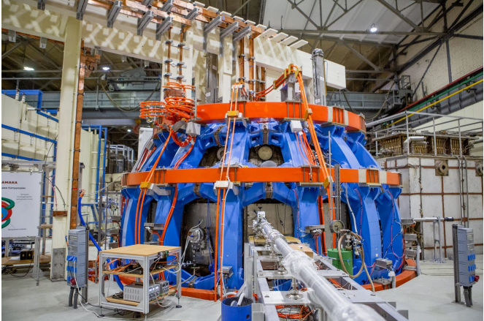
FIG. 1 T-15MD tokamak at the start of the first experimental campaign

The scientific program of the T-15MD tokamak is focused on the development of quasi-steady state regimes with high ion and electron temperature to create an experimental basis of thermonuclear power plants and fusion neutron sources based on tokamak concept.
The first experiments in T-15MD were carried out in March 2023, first plasma with I_{p}~30 kA was obtained and the ability to maintain a toroidal field of B_{T} = 1 T for 30 seconds was demonstrated [2]. For 2 years, the plasma currents up to 0.6 MA were reached (Fig. 2, a), in the range of toroidal magnetic field up to 1.5 T. Plasmas elongation of k > 1.5 was reached and discharges with LSN divertor configuration were obtained (Fig. 2, b) [3].
ECR assisted start-up on the 2nd ECR harmonic with P_{EC}=0.45-1 MW is used for plasma initiation.
a) | 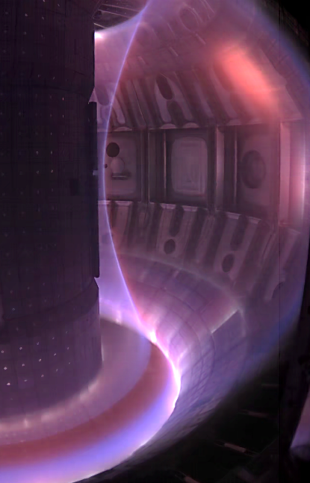  b)
Fig. 2 Overview of T-15MD results: a) increase in plasma current from year to year; b) shot 4563, visible light image of the plasma cross section with the LSN divertor configuration

REFERENCES

[1] KHVOSTENKO, P.P., et al., Experimental thermonuclear installation Tokamak T-15MD, Phys. of atomic nucl. 83 7 (2020) 1037-1057.
[2] VELIKHOV, E.P., et al., First Experimental Results on the T-15MD Tokamak, Phys. of atomic nucl. 87 1 (2024) S1-S9.
[3] KIRNEVA, N.A., et al., T-15MD: mission and recent experimental results, in Proc. Of 30th Fusion Energy Conference, October 13-18, 2025, Chengdu, China, IAEA-CN-316/3142

